Part 1: Project roadmap
Your roadmap is a one-page visual plan spanning both semesters, supported by a short narrative. Think of it as the picture you would show your client to explain how the next two semesters will go. Plan at the level of weeks to months, not days or individual tasks.

Required elements
- Phases. Break the project into 3–6 phases (for example: discovery, foundation, core features, integration, hardening, handoff). Give each phase a name, a goal, and approximate start and end dates.
- Major deliverables. List what each phase produces. Tie each deliverable to a scope item or objective from your charter.
- Workstreams. Show the parallel tracks of work (for example: front end, back end, data, testing, documentation). Use swimlanes or rows so overlaps are visible.
- Dependencies. Identify the major dependencies between deliverables, and any external dependencies (client data, access, hardware, third-party approvals).
- Semester boundary. Clearly show what will be complete at the end of Semester 1 and what Semester 2 begins with. Account for breaks and exam periods.
- Release or demo points. Mark when you will have something working to show the client. Plan for working software or product increments throughout, not a single big reveal at the end.

Supporting narrative (1–2 pages)
- Sequencing rationale. Why the phases are ordered the way they are. Address what you are doing early to reduce risk.
- Top risks to the schedule. The 3–5 things most likely to throw the plan off, and your response to each.
- Assumptions. What must be true for this roadmap to hold (team availability, client responsiveness, access to systems).
- What's not on the roadmap. Anything in the charter you are deferring or treating as a stretch goal.

Format
Present the roadmap in two views:
- Chevron diagram. Your phases as a left-to-right sequence of chevrons spanning both semesters. Label each chevron with the phase name, goal, approximate dates, and key deliverables. It must fit on one page — this is the view you would show your client.
- Gantt chart. Your deliverables, grouped by workstream, as bars on a week-by-week timeline across both semesters. Show durations, overlaps, dependencies between bars, the semester boundary and breaks, and demo points. Use any tool that produces a clean, readable chart (e.g., Excel, MS Project, GanttProject, or a project board's timeline view).

Example: LabLink equipment booking
This is a fictional capstone project, written at the level of detail this assignment expects. Match its depth, not its content — your project, phases, and diagrams will look different.
The project. LabLink is a web application that lets students reserve shared lab equipment in the department's three labs. A team of five is building it over two semesters for the department's lab manager.
Roadmap: chevron view
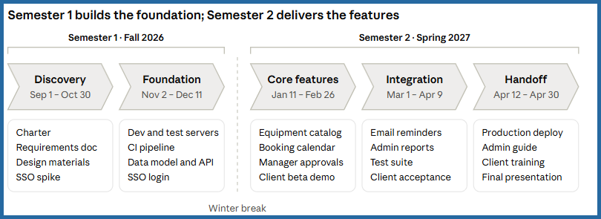
Five phases run left to right across both semesters; the box under each chevron lists what that phase delivers.
Roadmap: Gantt view
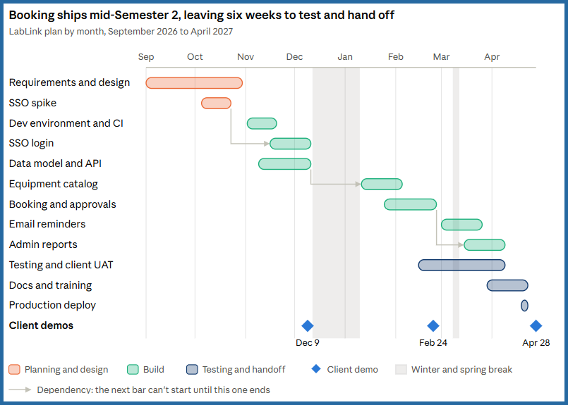

Each bar is a deliverable, colored by workstream; arrows mark the dependencies that drive the sequence, and diamonds mark the three client demos.
Roadmap narrative (excerpt)
Sequencing rationale. Campus single sign-on (SSO) is the riskiest dependency, so a spike proves it in October, before the design is final. Semester 1 ends with a "walking skeleton" — login, data model, and a deployed shell — so Semester 2 starts on features, not setup. Booking comes before reminders and reports because both depend on reservation data.
Top risks
Risk | Response
Campus IT takes more than 4 weeks to approve SSO access | Request access in week 3; build against a local login stub until approved
Client is unavailable for reviews | Standing 30-minute review every other Friday, agreed in the charter
Team capacity drops during midterms and finals | No new feature work planned in exam weeks; two weeks of buffer in Integration
Department server not ready by November | Deploy to a course-provided VM as a fallback

Assumptions. The client provides the equipment list by October 15. Department IT provides a test VM by November 1. Each team member averages 8–10 hours a week.
Not on the roadmap. A native mobile app, charging for equipment use, and university calendar integration are deferred as stretch goals.

